**Custom Checks**

健康检查跑自定义代码，并把报告状态发送到ServiceControl

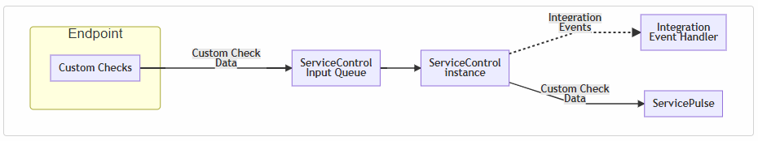

## Common scenarios for custom checks

1. Connectivity
2. Storage

## Set up custom checks

To enable custom checks in an environment:

1. [Install a ServiceControl instance](https://docs.particular.net/servicecontrol/servicecontrol-instances/) NServiceBus.CustomChecks

endpointConfiguration.ReportCustomChecksTo(

serviceControlQueue: "ServiceControl_Queue",

timeToLive: TimeSpan.FromSeconds(10));

1. Writing Custom Checks

**public** **class** **MyCustomCheck** : **CustomCheck**

1. Managing custom checks in ServicePulse

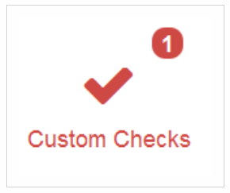

1. Optionally [subscribe to integration events from ServiceControl when custom checks succeed or fail](https://docs.particular.net/monitoring/custom-checks/notification-events)

## CustomCheckFailed/CustomCheckSucceeded

# Using ServiceControl Events